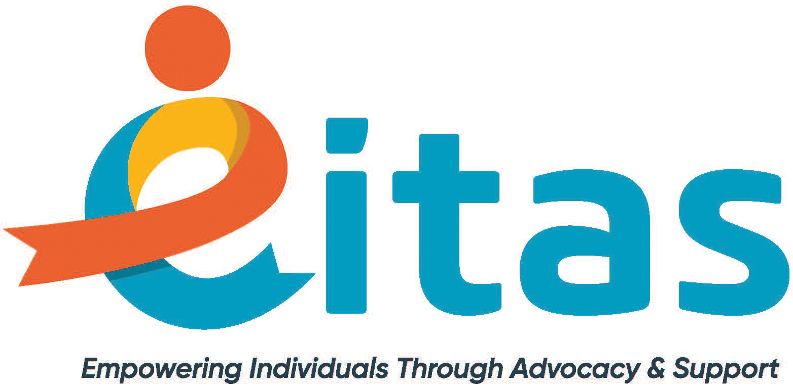
SB40 Funding Requests

SB 40 funding comes from a property tax levy paid by Jackson County residents. Request can be made to fund items in the below categories. An individual must be determined eligible for SB 40 funding to be considered for approval of funding. Funding is not guaranteed and is limited.

For more information contact Malinda Barnett at mbarnett@eitas.org

Temporary emergency residential supports or day programs:
- Temporary residential placement or day program services, in emergency situations
- Can fund up to $1,000.00 in costs
Adaptive equipment:
- Durable medical equipment, assistive technology, home modifications, and safety related items
- Can fund up to $1,000.00 in costs
Household items or rent deposit for individuals moving into their own residence:
- Funding is limited to individuals who are moving out on their own for the first time to an apartment or Individualized Supported Living setting
- Funding does not cover moving expenses.
- Household items up to $1000 in cost can be purchased OR
- Rent deposit up to $1000 in cost can be funded OR
- Combination of household items and rent deposit up to $1000 in cost can be funded
Emergency assistance:
- Funding is on a one-time basis per calendar year for emergency assistance. Emergency assistance funding is for addressing situations involving health and safety, and for meeting basic needs. Examples include utility bills; rent and mortgage payments; bug extermination; grocery items; and medications. Funding does not cover car repairs or car payments; internet bills; tax bills; and other possible bills.
- Funding up to $1000 can possibly be approved
Fitness memberships:
- The individual requesting funding needs to explore all location options to ensure he/she is receiving the best price, and if he/she has a support staff, that the support staff is able to attend with the individual at no cost.
- Funding is limited to $500/year
Dietician Consultation:
- Up to 3 hours of dietician services can be requested
- Funding is limited to $180.00 per request
Conference scholarships:
- Scholarships can only be funded for individuals with developmental disabilities. Family members, caregivers, and support staff cannot receive funding.
- Funding is limited to $200/year

